Subquery in mysql:
Rules:
The column written after where in the outer query must be logically and technically compatible with what the inner query returns.
This compatibility has three mandatory dimensions:
- What kind and how many count -- how many values are returned
- Data type -- what kind of values are returned
- Meaning --what those values represent
If anything mismatch it will throw error.
Universal Matching Table
Outer Condition | Inner SELECT must return
= | 1 column, 1 row
IN | 1 column, many rows allowed
> < | 1 numeric value
EXISTS | Any column (SELECT 1 is enough)

15 Subquery Examples based on return Type Focused
 | Outer WHERE condition | Subquery SELECT | What subquery returns | Result | Why
 | cust_id = | SELECT cust_id | 1 integer value | Valid | = expects one INT
 | cust_id IN | SELECT cust_id | Multiple integer values | Valid | IN allows many
 | amount = | SELECT MAX(amount) | One numeric value | Valid | Aggregate → single value
 | amount > | SELECT AVG(amount) | One numeric value | Valid | Comparison with scalar
 | cust_id = | SELECT MAX(cust_id) | One integer | Valid | Single-row result
 | cust_id = | SELECT cust_id FROM orders | Multiple integers | Error | = + multi-row
 | cust_id IN | SELECT cust_id FROM orders | Multiple integers | Valid | Correct operator
 | cust_id = | SELECT amount | Decimal value | Invalid logic | Meaning mismatch
 | amount = | SELECT cust_id | Integer | Invalid logic | Amount ≠ ID
 | cust_id = | SELECT COUNT(*) | One integer | Logical error | Count ≠ customer ID
 | amount > | SELECT MIN(amount) | One numeric value | Valid | Numeric comparison
 | cust_id IN | SELECT DISTINCT cust_id | Multiple integers | Valid | Proper multi-row
 | cust_id = | SELECT cust_id WHERE amount = MAX() | One integer | Valid | Single-row logic
 | EXISTS | SELECT 1 | Boolean existence | Valid | EXISTS ignores data

(=) Operator
Subquery must return exactly one value ,data type must match and meaning must match

in operator
Subquery returns multiple values in Only one column ,data type must match outer column

aggregate Functions (min,max,avg)
Will return single numeric value

Correlated subquery – inner query depend on outer query, and inner query doesn’t run independently.

Non correlated subquery – outer query doesn’t depend on inner query, and inner query run independently.
Scalar subquery,in subquery, any/all subquery.

Single Row Sub Query:
Based on Single Table:

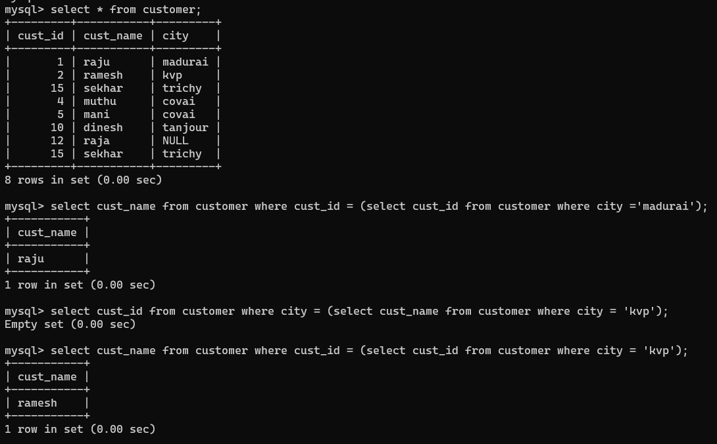

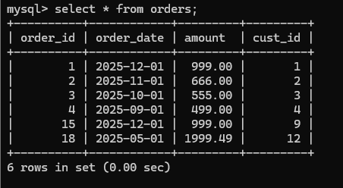
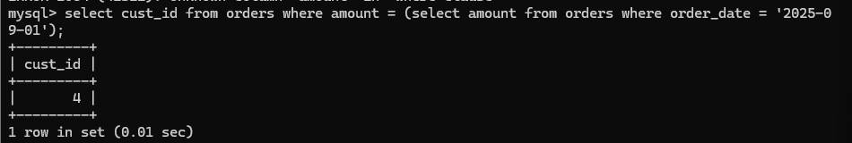
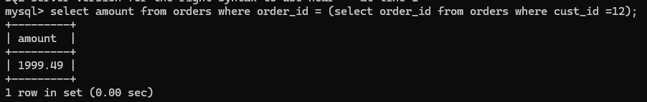
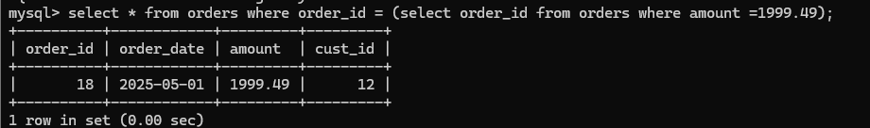
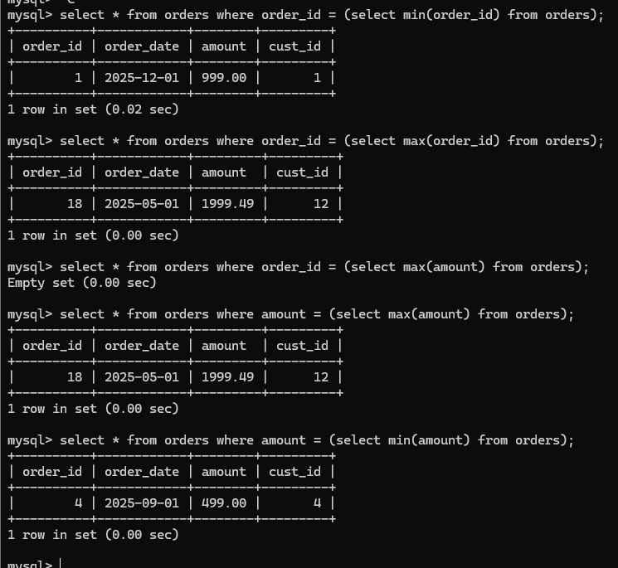
Based on Two Tables:
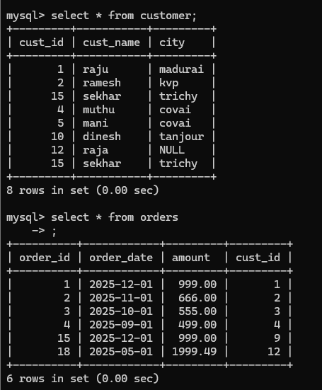

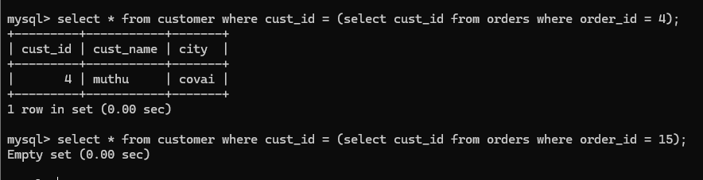

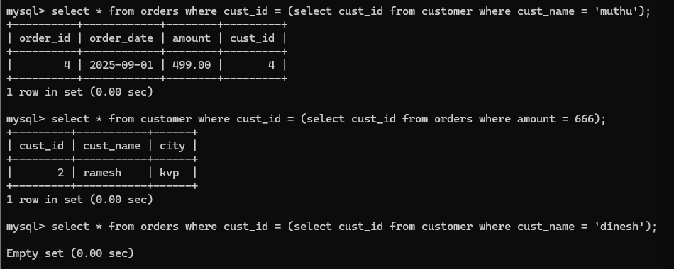
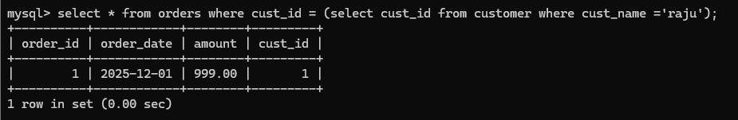
Multi Row SubQuery:
Subquery returns multiple columns:
Using IN:
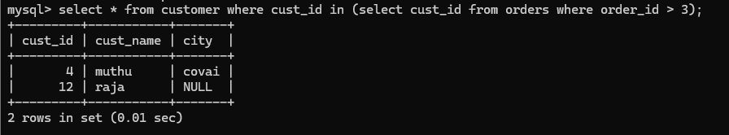
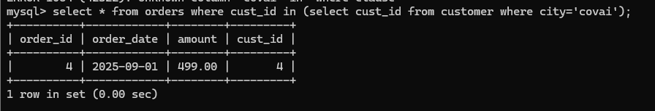
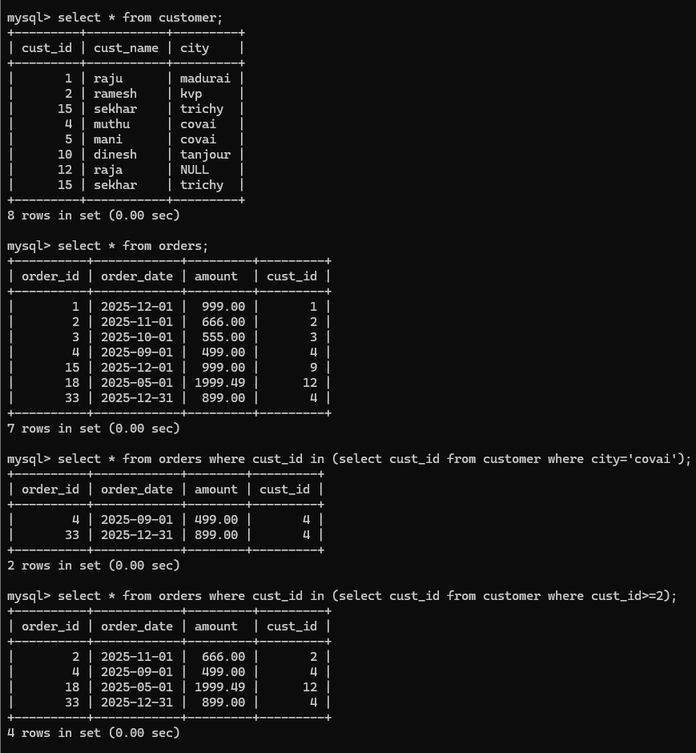

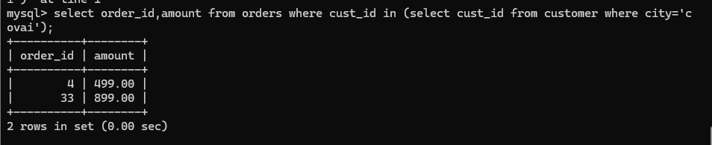
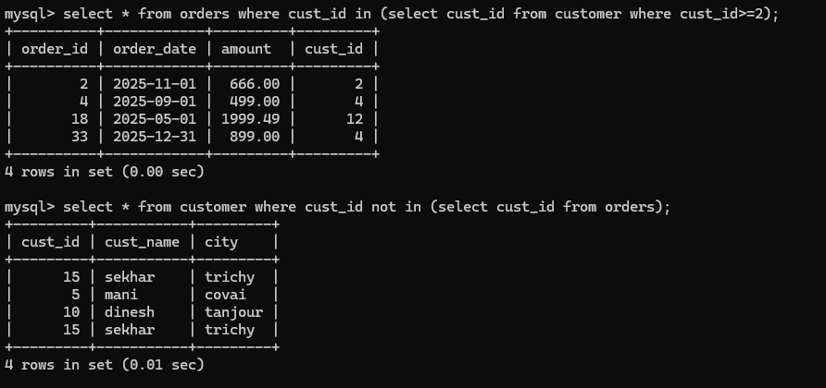

Coreleated Subquery:
Corelated subquery output result depend on the outer query

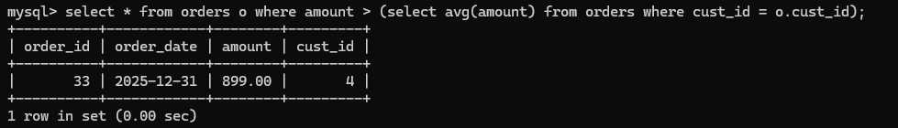

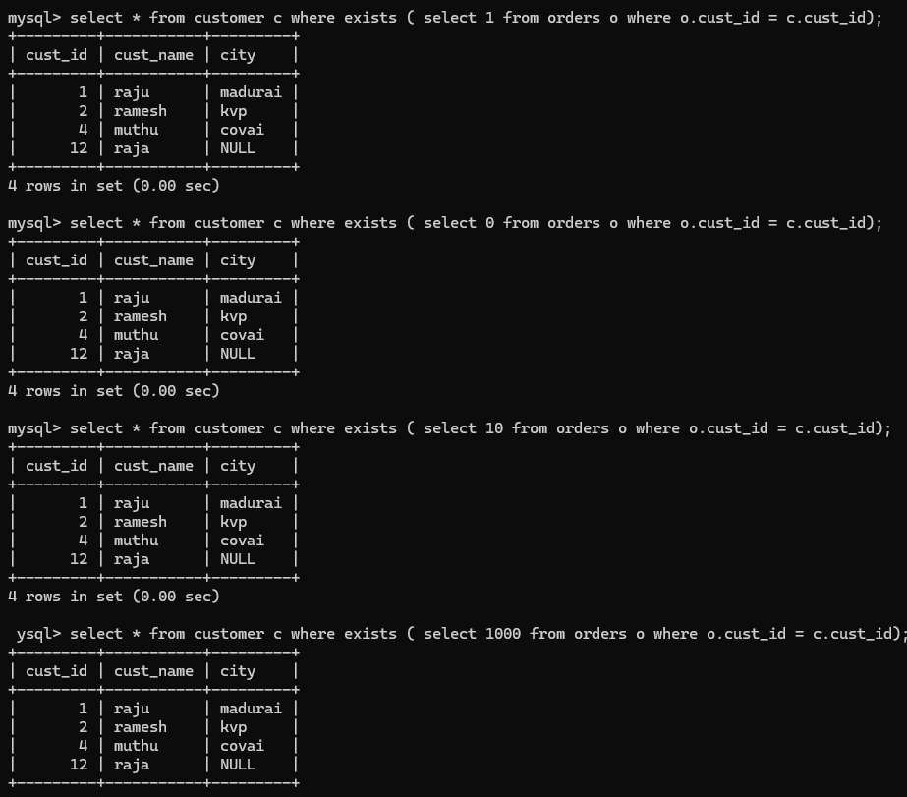
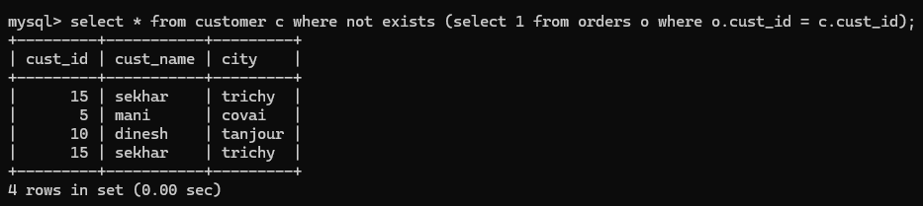

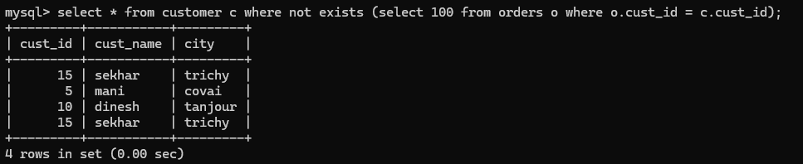
Subquery in select clause:

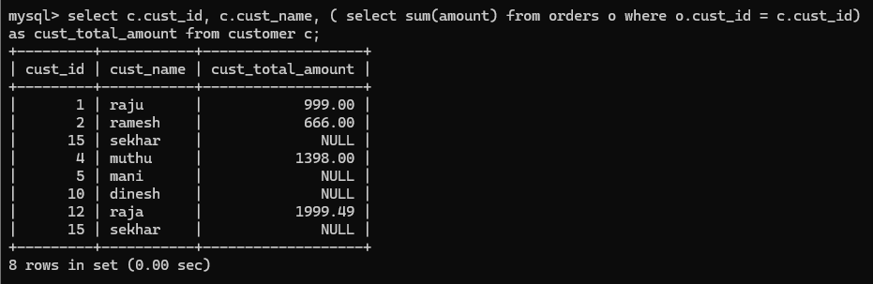

Nested sub queries:
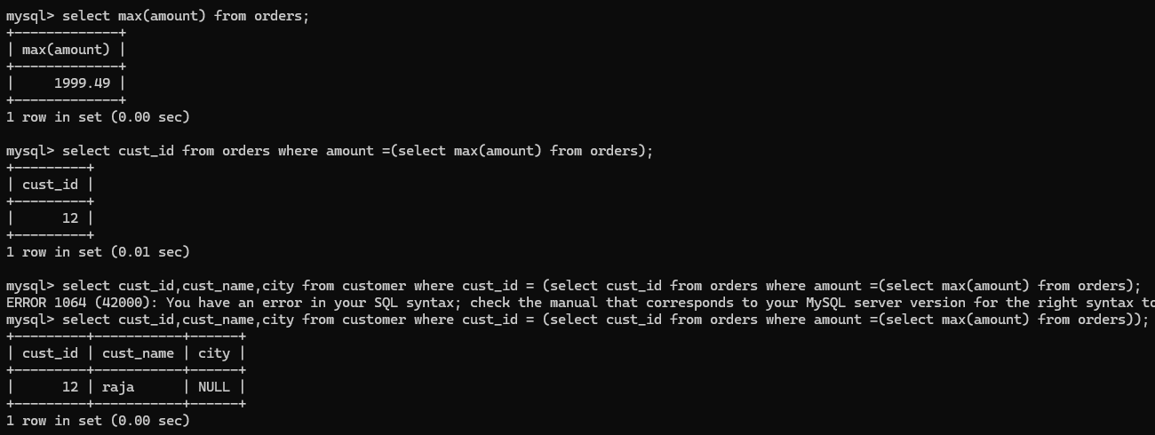




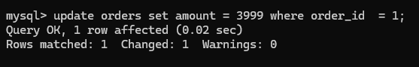

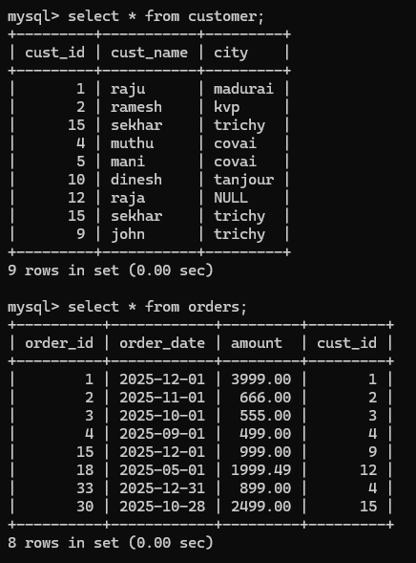

Subquery any / all:
